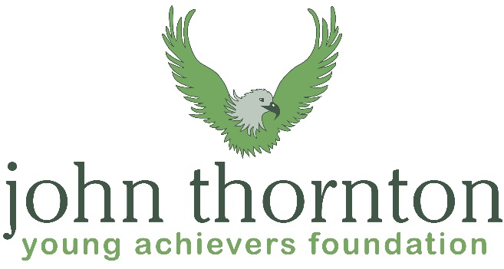
Marathon Effort for the John Thornton Young Achievers Foundation

The Challenge: Walk from Sandbanks to Lymington in 1 day as part of a fundraising team for the fantastic local charity – JTYAF.
*Half marathon option also available
The Charity: www.jtyaf.org – The JTYAF supports young people from a wide range of youth organisations providing them with scholarships and bursaries to support their personal development and the pursuit of their ambitions. Please support through JustGiving page link: https://www.justgiving.com/fundraising/marathoneffortforJT or sponsorship form.
£50 minimum per walker – aim high!
Arrangements: Meet Saturday, September 9th At Jazz’s Café, Sandbanks at 8.00am. The route will follow the coastal path with numerous toilet and refreshment opportunities. A steady pace with breaks will result in an arrival time at Lymington of 6.00. To mark the end point of the challenge we will have a pub meal at the Ship Inn with the return transport provided departing at 8pm, returning to Poole at 8.45.
Preparation: 26 miles is a challenge and will require some training. Please see the kiltwalk website for some excellent training tips (www.thekiltwalk.co.uk/advice/training)
On the day: Appropriate kit/footwear, water bottle, ferry/pub money
*Half Marathon options:
Option 1 Sandbanks – Highcliffe. Arriving at Highcliffe at approx.. 1.30. There are frequent returning buses.
Option 2 Highcliffe to Lymington. Meet at Highcliffe at 1.30 to join the adventure including pub and return minibus.
For further info / book a place please contact Joe Barnett
joenmel22@yahoo.co.uk / 07736442950

